No. | Answer
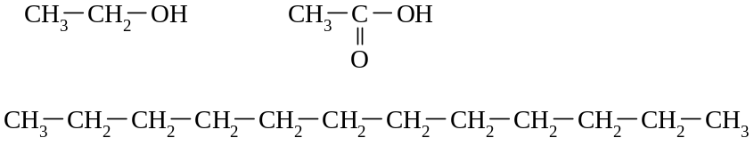
ethanol
acetic acid
kerosene

Ethanol: Hydrogen bonds and dispersion forces between the molecules.
Acetic acid: Hydrogen bonds and dispersion forces.
Kerosene: Dispersion forces only.
 | Each acetic acid molecule can form more hydrogen bonds (because of the double-bonded oxygen and the OH group) than an ethanol molecule (which only has one OH group).
 | Kerosene molecules are very large compared to the ethanol and acetic acid molecules. There will be many more electrons in the molecules in kerosene than in the molecules of the other two liquids. Therefore, the dispersion forces will be stronger than the dispersion forces and presumably the hydrogen bonds between the ethanol molecules and the acetic acid molecules.
 | If kerosene were to dissolve in water, the only forces that could form between the hydrocarbon molecules and the water molecules are dispersion forces. However, hydrogen bonds between the water molecules would have to break during the dissolving process so the hydrocarbon molecules can fit in between the water molecules. Presumably, these hydrogen bonds are stronger than the dispersion forces that would form. When acetic acid dissolves in water, hydrogen bonds are broken, between water molecules and between acetic acid molecules, but new hydrogen bonds can form between the acetic acid and water molecules.
When the acetic acid behaves as an acid, the shared electrons between the O and H in the
O–H bond are attracted more by the electronegative O atom, making it ‘easy’ for the H⁺ to form (this H⁺ is actually attracted to the O atom in a H₂O molecule). The presence of a second electronegative oxygen atom in the acetic acid molecule causes the electrons in the O–H bond to be even more unequally shared. An ethanol molecule also has an O–H bond, but it does not have the additional O atom in its molecule to contribute to the shared electrons being ‘pulled away’ from the H atom.
 | With the possibility of more hydrogen bonds forming between acetic acid molecules than between ethanol molecules (and the larger number of electron in acetic acid molecules, therefore stronger dispersion forces), the intermolecular forces between acetic molecules will be stronger than between ethanol molecules. These stronger forces will pull the acetic acid molecules closer together, resulting in there being a larger mass present in a particular volume. (Also because of the structure of acetic acid molecules, they are able to fit closer together compared to the ethanol molecules.)
 | Volume of ethanol in 30 mL of the whiskey = 30 × = 13.5 mL
Ethanol: C₂H₅OH(g) + 3O₂(g) → 2CO₂(g) + 3H₂O(g)
Acetic acid: CH₃CO₂H(g) + 3O₂(g) → 2CO₂(g) + 2H₂O(g)
Kerosene (using a typical molecule): 2C₁₂H₂₆(g) + 37O₂(g) → 24CO₂(g) + 26H₂O(g)
a Because it is a polar molecule and yet has a non-polar ‘tail’, it can dissolve both polar and non-polar substances. It also evaporates more readily than water, allowing the cleaned item to dry quicker.
b The acidic conditions that exist in the sauce because of the acetic acid either kill the microbes, that may cause the sauce to ‘go rotten’, or prevent them from growing.
c Kerosene is a non-polar liquid and so will dissolve other non-polar substances such as oil or grease.
d Kerosene is flammable and also releases a large amount of heat when it is burnt.

